## CHAPTER 1

# INTRODUCTION

In recent years, the intersection of medical imaging, image processing, and machine learning has paved the way for revolutionary advancements in the diagnosis and treatment of various medical conditions. One of the most critical areas benefiting from these interdisciplinary approaches is the detection and analysis of brain tumors. Brain tumors represent a significant health concern globally, and their timely and accurate diagnosis is imperative for effective medical intervention.

Traditional methods of brain tumor detection often rely on manual examination of medical images such as Magnetic Resonance Imaging (MRI) and Computed Tomography (CT) scans. However, the increasing volume and complexity of medical data, coupled with the need for precision in diagnosis, necessitate more sophisticated and automated techniques. This has led to the integration of digital analysis, image processing, and machine learning algorithms in the field of neuroimaging, providing a promising avenue for enhanced diagnostic accuracy and efficiency.

This research focuses on leveraging the power of image processing and machine learning techniques to develop a comprehensive and automated system for the digital analysis of brain tumors. The integration of these technologies aims to address the limitations of conventional diagnostic methods, offering a more efficient, objective, and reliable approach to tumor detection and classification.

The primary objectives of this study include the development of robust image processing algorithms for the extraction of relevant features from medical images, the implementation of machine learning models for the classification of brain tumors based on these features, and the validation of the proposed system's efficacy through extensive testing on diverse datasets. By harnessing the capabilities of digital analysis, this research seeks to contribute to the advancement of neuroimaging practices, ultimately improving the accuracy and speed of brain tumor diagnosis.

As we deep dive into the intricacies of digital analysis, image processing, and machine learning in the context of brain tumor detection, we anticipate that the outcomes of this research will not only enhance our understanding of these innovative technologies but also significantly impact the landscape of clinical neurology and medical imaging. The potential benefits include early and precise diagnosis, personalized treatment planning, and improved patient outcomes in the challenging realm of brain tumor management.

### Purpose of Project

The project "Digital Analysis of Brain Tumor Using Image Processing and Machine Learning" serves a multifaceted purpose aimed at revolutionizing the diagnosis and treatment of brain tumors. One key objective is to significantly enhance diagnostic accuracy by leveraging advanced image processing algorithms. These algorithms are designed to meticulously extract relevant features from medical images, such as MRI and CT scans, providing a nuanced understanding of the tumor's characteristics.

Integrating machine learning into the diagnostic process is another pivotal goal. By employing machine learning models, the project seeks to enable automated and precise classification of brain tumors based on the extracted features. This not only expedites the diagnostic timeline but also contributes to reducing the likelihood of misdiagnosis.

Efficiency is a central theme, with the project striving to streamline the diagnostic workflow. Automation allows healthcare professionals to focus more on treatment planning and patient care, transforming the diagnostic paradigm from labor-intensive manual methods to a technologically advanced, time-efficient approach.

The project's robustness and applicability across diverse scenarios are ensured through rigorous validation using a variety of datasets. By testing the system on datasets with varying patient demographics and tumor characteristics, the project aims to establish its reliability and generalizability in real-world clinical settings.

Ultimately, the project aspires to advance neuroimaging practices, contributing to the ongoing evolution of medical technology. By providing a sophisticated tool for early and accurate brain tumor diagnosis, the project seeks to have a tangible impact on clinical neurology, fostering improved treatment strategies and outcomes for patients grappling with the complexities of brain tumors

### Existing System

The current system for diagnosing brain tumors relies on manual interpretation of medical images like MRI and CT scans, introducing subjectivity and time constraints. This traditional approach is inherently limited by the variability in human interpretation, making it challenging to ensure consistent and accurate diagnoses. Furthermore, the manual analysis of a growing volume of medical data is time-consuming, potentially delaying critical interventions.

In response to these limitations, the proposed project seeks to innovate the existing system by integrating digital analysis, image processing, and machine learning. These technologies aim to overcome the shortcomings of manual interpretation by providing a more objective and efficient approach to brain tumor diagnosis. The project's goal is to automate and enhance the

diagnostic process, utilizing advanced algorithms to extract and analyze relevant features from medical images. By introducing these technological advancements, the project aims to improve diagnostic precision, reduce reliance on subjective assessments, and expedite the overall diagnostic timeline, ultimately contributing to more effective and timely treatments for patients with brain tumors.

### Proposed System

The proposed system for the digital analysis of brain tumors represents a paradigm shift in diagnostic methodologies, integrating cutting-edge technologies to overcome the limitations of the existing manual approach. Leveraging image processing and machine learning, the system aims to enhance diagnostic accuracy, efficiency, and objectivity.

The cornerstone of the proposed system is the implementation of robust image processing algorithms designed to extract intricate features from medical images, such as MRI and CT scans. These features serve as vital inputs for machine learning models, enabling the system to discern complex patterns and nuances indicative of various brain tumor types.

The introduction of machine learning classification further refines the diagnostic process. The system will autonomously categorize tumors based on learned patterns, providing a more standardized and consistent approach compared to manual interpretation. This not only reduces the subjectivity associated with human assessments but also significantly accelerates the diagnostic timeline.

By validating the proposed system across diverse datasets, encompassing varying patient demographics and tumor characteristics, the project aims to establish its reliability and generalizability in real-world clinical settings. Ultimately, the proposed system seeks to redefine neuroimaging practices, offering a comprehensive and automated solution that improves the accuracy, efficiency, and overall effectiveness of brain tumor diagnosis, thereby contributing to better patient outcomes.

## CHAPTER 2

# LITERATURE SURVEY

#### Automatic Segmentation of Rare Pediatric Brain Tumors Using Knowledge Transfer from Adult Data paper [1]

The paper explores the challenge of automatic segmentation for Diffuse Midline Glioma (DMG), a rare yet life-threatening pediatric brain tumor. Recognizing the potential of deep learning models, the study investigates knowledge transfer from adult brain tumor data to enhance segmentation accuracy for pediatric cases. With a limited dataset of 45 children diagnosed with DMG, involving 82 MRI scans at various timepoints, the research adopts a five-fold cross-validation approach.

Two state-of-the-art deep learning models, SegResNet and nnU-Net, are employed, both with and without pretraining on the BraTS2021 dataset consisting of 1,251 glioblastoma multiform subjects. The findings indicate that the nnU-Net model, when pretrained, achieves the most favorable segmentation results, boasting Dice scores of 0.859±0.229 for the enhancing region and 0.880±0.072 for the entire tumor. This suggests that transferring knowledge from adult brain tumor images significantly enhances the performance of segmentation tasks in pediatric brain tumor cases.

Furthermore, the study highlights the efficiency gains achieved through pretraining, demonstrating accelerated training convergence for downstream tasks. The implementation of an automatic pipeline for DMG segmentation, informed by knowledge transfer from adult data, holds promise for monitoring tumor progression and predicting overall survival in pediatric patients. This approach addresses the scarcity of pediatric data by leveraging insights gained from adult brain tumor datasets, showcasing its potential as a valuable tool in clinical settings for improved diagnosis and treatment planning for rare pediatric brain tumors.

### Radiomic Features Based on MRI Predict Progression-Free Survival in Pediatric Diffuse Midline Glioma/Diffuse Intrinsic Pontine Glioma[2]

The paper discusses a study aiming to assess the potential of radiomics as a prognostic marker for predicting survival outcomes in pediatric patients with Diffuse Intrinsic Pontine Glioma (DIPG). Traditionally, biopsy-based assessment of H3 K27 M status has been a keyfactor in predicting survival; however, biopsy procedures are often limited to unusual presentations and clinical trials. This study explores an alternative approach by leveraging radiomic features extracted from diagnostic brain MRIs of children with DIPG.

The retrospective analysis involves 89 patients, with molecular data available for 29.2% of

them. The median age at diagnosis is 6.64 years, and the median progression-free survival (PFS) is 8 months. Radiomic features from FLAIR and nonenhanced T1-weighted sequences prove to be predictive of PFS. The study employs a conditional survival forest model for prediction, with training and testing data split in an 80:20 ratio.

The findings reveal that the best FLAIR radiomics model achieves a high concordance of .87 at 4 months PFS, while the best T1-weighted radiomics model attains a concordance of .82 at 4 months PFS. Combining FLAIR and T1-weighted radiomics yields a concordance of .74 at 3 months PFS. Gray-level size-zone emerges as a significant predictive radiomic feature.

In conclusion, the study demonstrates that MRI-based radiomics has the potential to serve as a valuable prognostic tool for predicting progression-free survival in pediatric DIPG cases. By leveraging radiomic features from routine diagnostic imaging, this approach offers a non- invasive and potentially more accessible method for stratifying DIPG subsets and predicting survival outcomes in pediatric patients.

#### A robust segmentation algorithm using morphological operators for detection of tumor in MRI [3]

This paper delves into the critical realms of medical image processing, specifically focusing on two pivotal areas: Image Denoising and Image Segmentation. The primary objective of the study is to formulate a robust segmentation algorithm designed for the detection of tumors in 2D MRI brain images. Recognizing the paramount role of noise in influencing the accuracy of affected areas, particularly in the context of medical diagnostics, the paper strategically employs image denoising as a preprocessing step.

The denoising process is executed through the utilization of a fourth-order partial differential equation. This sophisticated mathematical approach serves to effectively reduce noise in the MRI brain images, laying a foundation for more precise and reliable segmentation results.

The segmentation algorithm employed is seeded region growing, a technique known for its efficacy in detecting tumors in medical images. This method enables the algorithm to identify and isolate tumor regions within the MRI brain images accurately. Notably, the paper introduces an additional enhancement by incorporating a skull removal procedure using morphological operators. This step is crucial for refining the accuracy of brain tumor detection, eliminating potential interference from non-tumor structures and further improving the segmentation process.

The proposed method is systematically tested across several brain tumor images, demonstrating its efficiency and reliability in detecting tumors in the brain images. The utilization of advanced denoising techniques, coupled with a meticulous segmentation algorithm and skull removal procedure, collectively contributes to the effectiveness of the proposed approach. By addressing the challenges posed by noise and refining the segmentation process, this method holds promise for enhancing the accuracy of brain tumor detection in 2D MRI brain images, thus advancing the field of medical image processing for improved diagnostic outcomes.

**CHAPTER 3**

**SYSTEM REQUIREMENTS**

### Software Requirements:

**Operating System:** Windows 8 or above, Linux and Mac

**Programming Language:** Python

#### Drivers:

**Tools:** Jupyter Notebook, vs code

### Hardware Requirements:

**Processor**: i5

**Memory:** Hard Disk-250Gb, Memory -8GB RAM

**Any Other Device:** NO

**CHAPTER 4**

**SYSTEM ARCHITECTURE AND DESIGN**

* 1. **TECHNOLOGY USED:**
* **Python:** Python was the language of selection for this project. This was a straight forward call for many reasons.
  1. Python as a language has a vast community behind it. Any problems which may be faced is simply resolved with a visit to Stack Overflow. Python is among the foremost standard language on the positioning that makes it very likely there will be straight answer to any question
  2. Python has an abundance of powerful tools prepared for scientific computing Packages like NumPy, Pandas and SciPy area unit freely available and well documented. Packages like these will dramatically scale back, and change the code required to write a given program. This makes iteration fast.
  3. Python as a language is forgiving and permits for program that appear as if pseudo code. This can be helpful once pseudo code given in tutorial papers must be enforced and tested. Using python this step is sometimes fairly trivial. However, Python is not without its errors. The language is dynamically written and packages are area unit infamous for Duck writing. This may be frustrating once a package technique returns one thing that, for instance, looks
  4. like an array instead of being an actual array. Plus, the actual fact that standard Python documentation does not clearly state the return type of a method, this can lead to a lot of trials and error testing that will not otherwise happen in a powerfully written language. This is a problem that produces learning to use a replacement Python package or library more difficult than it otherwise may be.
* **Jupyter Notebook:** The Jupyter Notebook is an open-source web application that enables you to make and share documents that contain live code, equations, visualizations and narrative text. Uses include: data cleaning and transformation, numerical simulation, statistical modelling, data visualization, machine learning, and much more.
* **Noise Removal and Sharpening:** Unwanted data of element are remove using filter and image Can be sharpen and black and white grey scale image is used as a input.
* **Erosion and Dilation:** It is applied to binary image, but there are many versions so that can be work on grayscale images. The basic effect of the operator on a binary image is eroding away to the boundaries of regions for ground pixels.
* **Negation:** A negative is an image, usually it used on a strip or sheet of transparent plastic film, in negation the lightest areas of the photographed subject appear darkest and the darkest areas appear lightest.
* **Subtraction:** Image subtraction process is the digital numeric value of one pixel or whole image is subtracted from another image. The white part of tumor can be subtracted from another remaining part that is the black portion of the images.
* **Threshold:** Thresholding is a process of image segmentation. It converts the gray scale image into binary image.
* **Boundary Detection:** Total area or boundary can be form properly using boundary detection method. White part of tumor tissues can be highlighted and their proper boundary can be detected. It is useful method to calculate the size and shape occupy by tumor tissues.

### Design

* + 1. **: Architecture Design:**

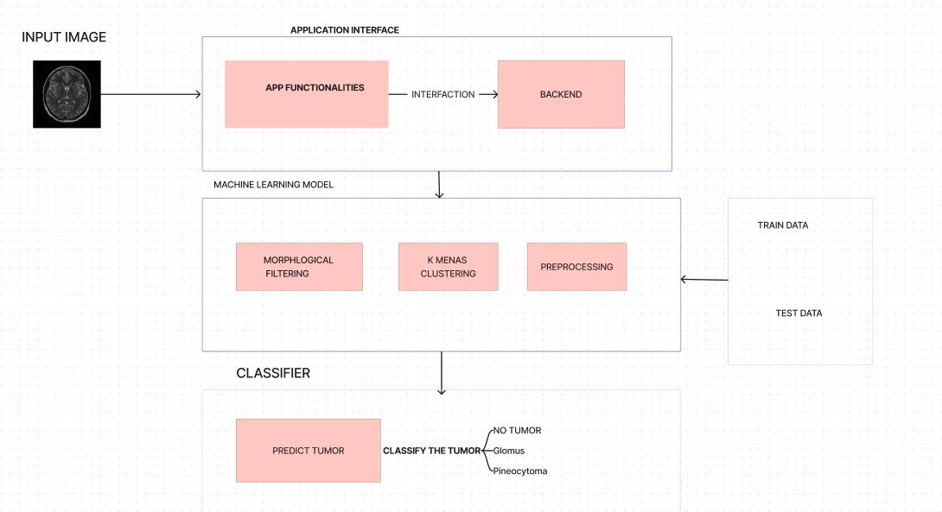The architecture of the system is categorized into three modules. These modules work together to get the final results. The working and description about each module are as follows:

### Fig 4.2.1: Architecture Design of proposed system

The architecture of the system is categorized into three modules. These modules work together to get the final results. The working and description about each module are as follows:

**Application Interface:** The application interface functions as the primary layer in the architecture, overseeing user interaction. Its core responsibilities encompass obtaining image input from the user, transmitting it to the system's backend for disease identification, and displaying the results received from the backend. This interaction is facilitated through the utilization of a REST API defined by the backend.

#### Key Functions:

1. **Image Input Handling**: The interface seamlessly acquires image input from the user, serving as the initial point of interaction for disease prediction.
2. **Communication with Back-end:** Using the REST API established by the backend, the interface transmits the user-provided image data, ensuring a smooth flow of information to the disease identification system.
3. **Result Display:** Once the backend completes the disease identification process, the interface displays the results, offering users a clear and comprehensible presentation of the findings.
4. **Information Dissemination:** The interface serves as an information hub, providing details about various diseases. Users can access valuable insights into different medical conditions.
5. **Step-by-Step Guide:** Offering a user-friendly experience, the interface guides users through a step-by-step process for predicting tumors. This feature ensures a seamless and intuitive user journey.

#### MACHINE LEARNING MODULE:

Central to our system architecture is the Machine Learning Module, a dynamic powerhouse designed to predict brain tumors with precision. This module orchestrates a seamless process, initiated by the image received by the backend.

#### Morphological Filters and K-Means Clustering Component:

The image undergoes processing within the Morphological Filters and K-Means Clustering component, a departure from traditional data augmentation methods. In this crucial step, morphological filters enhance image features, while K-Means Clustering categorizes and groups pixel intensities. This innovative approach enriches the dataset by imbuing the image with meaningful structural information.

#### Preprocessing with Skull Removal:

Prior to feature extraction, the image undergoes preprocessing with skull removal. This step enhances the clarity and focus of the image, optimizing it for subsequent analysis.

#### Image Enhancement:

The refined image, now devoid of the skull, is subjected to image enhancement techniques. This stage focuses on improving visual quality and highlighting critical details that contribute to more accurate tumor predictions.

#### Classifier Module Overview for Brain Tumor Detection:

The classifier Module functions as the subsequent phase in our system, receiving inputs from the Machine Learning Module and categorizing the disease type based on the obtained output. Upon successful disease identification, a query is initiated within the dedicated brain tumor database. This database contains information about the identified disease, along with corresponding remedies, which are then transmitted back to the server for further processing.

To conclude, the Classifier Module plays a pivotal role in determining the type of brain tumor detected, utilizing a comprehensive database to provide pertinent remedies. This seamless integration ensures a prompt and accurate response to the identified medical condition.

* + 1. **: USE CASE Diagram:**

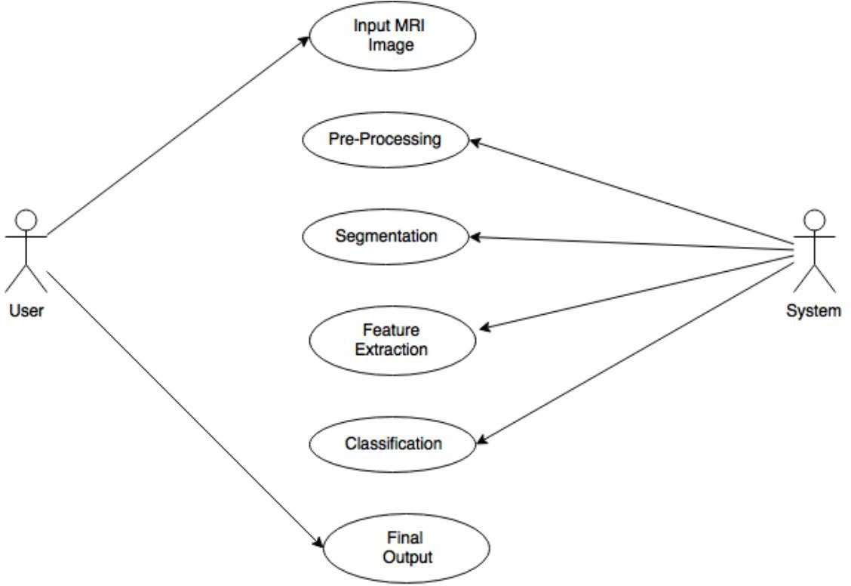

### Fig:4.2.2 Use Case Diagram

The use case diagram illustrates the key interactions and functionalities within the Brain Tumor Detection System, incorporating two primary actors and various components of the detection

process.

Actors:

#### Medical Professional (User):

* + - * + Description: This actor represents the medical professional who interacts with the system to input data, receive results, and make informed decisions based on the brain tumor detection process.
        + Use Cases:

Input Patient Data

View MRI Results

Access Disease Classification Information

#### System Components:

* + - * + Description: These components represent the integral stages and processes involved in the brain tumor detection system.
        + Use Cases:
* MRI: Represents the MRI component as an input source for brain images.
  + - * + Preprocessing: Includes actions such as skull removal to enhance the quality of the MRI images.
        + Image Enhancement: Involves techniques to improve the visual quality and clarity of the brain images.
        + Segmentation: Defines the process of segmenting the brain images to isolate the potential tumor regions.
        + Feature Extraction: Encompasses the extraction of relevant features from the segmented regions. Classification: Involves the classification of the extracted features to identify the type of brain tumor.

#### Interactions:

1. **Input Patient Data:**
   * Actor: Medical Professional
   * System Components: MRI, Preprocessing, Image Enhancement

#### View MRI Results:

* + Actor: Medical Professional
  + System Components: Image Enhancement, Segmentation, Feature Extraction

#### Access Disease Classification Information:

* + Actor: Medical Professional
  + System Components: Feature Extraction, Classification

The use case diagram visually captures the flow of actions and interactions between the medical professional and the system components during the brain tumor detection process. It provides a clear representation of how each actor contributes to and benefits from the various stages of the detection system

**4.2.3: Sequence Diagram**

A sequence diagram is an interaction diagram that shows how and in what order the processes interact. This is the construction of message sequence diagrams, sometimes called event diagrams, event scenarios, and sequence diagrams.

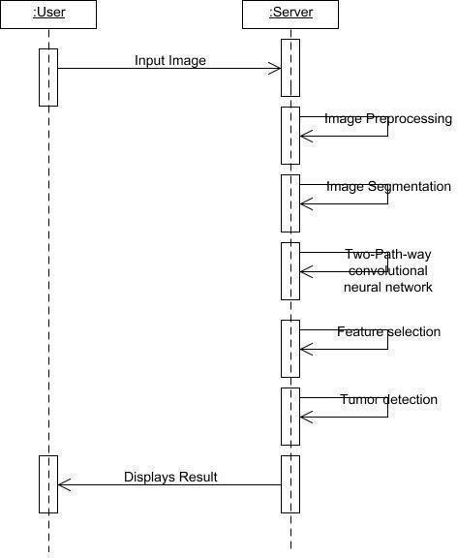

**Fig:4.2.3 Sequence Diagram**

**CHAPTER 5:**

## SYSTEM IMPLEMENTATION

We used various datasets to train the model. Our proposed method mainly separated into stages, preprocessing, Model Construction, Training & Validation, Model Evaluation & Prediction. Since the loading dataset is necessary for any process, all the steps come after it

#### Basic Architecture:

There are two main parts to a CNN architecture

* A convolution tool that separates and identifies the various features of the image for analysis in a process called as Feature Extraction.
* A fully connected layer that utilizes the output from the convolution process and predicts the class of the image based on the features extracted in previous stages.

Description of CNN Layers:

The multiple occurring of these layers shows how deep our network is, and this formation is known as the deep neural network.

* Input: raw pixel values are provided as input.
* Convolutional layer: Input layers translates the results of the neuron layer. There is a need to specify the filter to be used. Each filter can only be a 5*5 window that slides over input data and gets pixels with maximum intensities.
* Rectified linear unit [ReLU] layer: provided activation function on the data taken as an image. In the case of back propagation, ReLU function is used which prevents the values of pixels from changing.
* Pooling layer: Performs a down-sampling operation in volume along the dimensions (width, height).
* Fully connected layer: score class is focused, and a maximum score of the input digits is found. As we go deeper and deeper in the layers, the complexity is increased a lot. But it might be worth going as accuracy may increase but unfortunately, time consumption also increases.

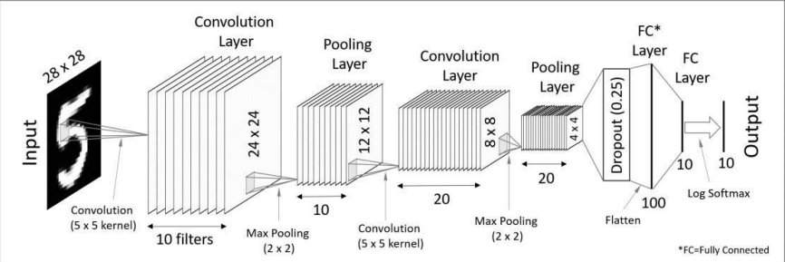

**Fig:5.1** Convolutional Neural Network layer.

### Image Enhancement

Image Enhancement plays a critical function in improving the quality and contrast of medical images in the field of brain tumor identification. Histogram Equalization, a strategy that maximizes the overall visual appeal of the image by redistributing pixel intensities, is one strong technique used for this goal. Contrast-Limited Adaptive Histogram Equalization (CLAHE), done using the adapthisteq function, is a more advanced technique.

Unlike standard histogram equalization, which operates evenly on the entire image, CLAHE employs a targeted technique. It divides the image into small sections called tiles and increases the contrast inside each tile. This localized improvement ensures that each region's histogram approximates a given goal histogram.

The importance of this rests in the capacity to catch minute details and variances in various sections of the image, which is especially useful in the setting of brain tumor identification where nuanced anomalies may exist. Furthermore, CLAHE introduces a critical technique to counteract potential noise amplification throughout the enhancement process. The adapthisteq function guarantees that the overall augmentation does not accidentally exaggerate unnecessary details or artifacts by minimizing contrast, particularly in homogeneous areas where noise may be more pronounced. In the context of brain tumor diagnosis, where accurate and exact interpretation of medical pictures is critical, Contrast-Limited Adaptive Histogram Equalization stands out as a complex and practical method of improving image visual quality. This approach contributes to the enhancement of contrast, enabling medical professionals to discern subtle features and abnormalities, ultimately facilitating a more accurate and reliable diagnosis

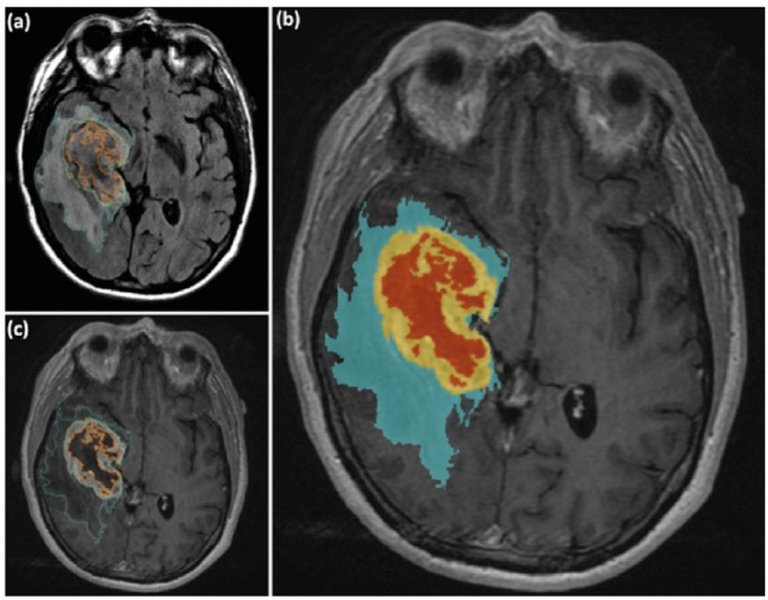

**Fig:**5.2.1 (a) Axial FLAIR image demonstrates segmentation (in blue) of the region corresponding to the area of tumor infiltration. (b) The segmented edema/tumor infiltration (blue), enhancement (yellow) and necrosis (orange) are seen. (c) Axial post-contrast enhanced the segmentation of the enhancement (yellow) and necrosis (orange).

#### Morphological operation

Morphological Operations are an important step after MRI picture segmentation in the context of brain tumor identification. Segmentation frequently leads in unwanted white components, groups of pixels that are not part of the tumor, and Morphological Operations such as erosion and dilation are critical in refining the segmentation findings. Dilation is a morphological procedure that includes adding pixels to the edges of objects inside an image. Dilation successfully widens the bounds of potential tumor zones in the context of brain tumor identification, helping to unite fragmented areas and generate a more cohesive depiction of the tumor. This approach is especially useful for capturing the full tumor structure. In contrast, another morphological technique, erosion, eliminates pixels along the object borders. This technique helps to remove unnecessary white components while also refining the segmentation by decreasing the identified sections. The structuring element, or strel, used during image processing determines the efficiency of erosion and dilation. The number of pixels added or subtracted from the objects in the image is determined by the size and shape of the strel. It is critical to fine-tune the strel parameters to achieve optimal outcomes in the elimination of undesirable components while keeping key tumor features.

The image resulting from the application of erosion and dilation depicts the final tumor segmentation. This improved image is well-prepared for feature extraction methods in the future. Morphological Operations play an essential role for enhancing the accuracy and reliability of brain tumor identification by ensuring that the segmented regions accurately portray the tumor.

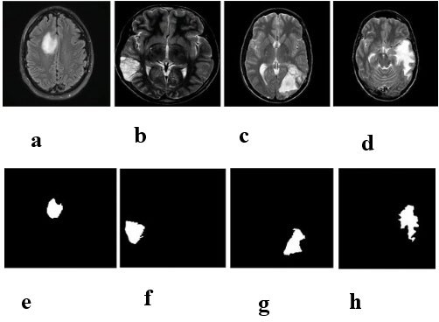

**Fig:5.3.1: a-d Original MRI Scan,**

**e-h images after morphological operations**

### : Feature Extraction

Discrete Wavelet Transform (DWT) and Principal Component Analysis (PCA) with Gray-Level Co-occurrence Matrix Algorithm (GLCM) The discrete wavelet transform (DWT) is a powerful implementation of the WT using the dyadic scales and positions. The fundamentals of DWT are introduced as follows. Suppose x(t) is a square-integrable function, then the continuous WT of x(t) relative to a given wavelet ψ(t) is defined as

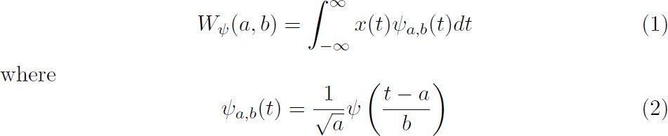

Here, the wavelet ψa,b(t) is calculated from the mother wavelet ψ(t) by translation and dilation: a is the dilation factor and b the translation parameter (both real positive numbers). There are several different kinds of wavelets which have gained popularity throughout the development of wavelet analysis. The most important wavelet is the Harr wavelet, which is the simplest one and often the preferred wavelet in a lot of applications.

GLCM is a widely used method for medical image analysis, classification. This method gives us information about relative position of two pixels with respect to each other. The GLCM is then created by counting the number of occurrences of pixel pairs at a certain distance. To compute the GLCM matrix for an image f (i, j), a distance vector d= (x, y) is defined. The (i,j)th element of the GLCM matrix P is defined as the probability that grey levels i and j occur at distance d and angle θ, then extracting texture features from GLCM matrix P. Four angles (0,45,90,135) and four distances (1,2,3,4) can be used to calculate the co-occurrence matrix.

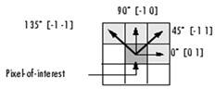

#### Fig:5.4.1: Calculation of correlation matrix

The extracted features are:

#### Correlation:

It measures the linear dependency of grey levels of neighboring pixels. It is defined in Eq.1

Eq-1

1. **Contrast**

Also called the sum of Square Variance. It defers the calculation of the intensity contrast linking pixel and its neighbor over the whole image. It is defined in Eq. 2

Eq-2

1. **Mean**

Defined as the mean of the pixel values of the input image. It is defined in Eq. 3

Eq-3

### Classification

* + 1. **: Support vector machine:**

Support vector machines (SVMs) are a type of supervised learning models along with associated learning algorithms that analyse data and recognize various patterns, used for classification analysis. The basic SVM takes a set of input data and predicts, for each given input, which of two possible classes, malignant and benign forms the output, making it a non-probabilistic binary linear classifier. Now that there are set of training examples at hand, each marked as belonging to one of two categories, an SVM training algorithm constructs a model that assigns new examples into one category or the other. An SVM model is a representation of the examples as points in space, mapped so that the examples of the separate categories are divided by a clear gap that is as wide as possible. Newer examples are then plotted into it and then predicted to belong to a category based on which side of the gap they fall on.

More formally, a support vector machine constructs a hyper plane or set of hyper planes in a high- or infinite-dimensional space, which can be used for classification, regression, or other tasks. Intuitively, a good separation is achieved by the hyper plane that has the largest distance to the nearest training data point of any class (so-called functional margin), since in general the larger the margin the lower the generalization error of the classifier. A SVM takes a set of feature vectors as input, generates a training model after scaling, selecting and validating, and generates a training model as the output. The following figure represents the training process of a SVM:

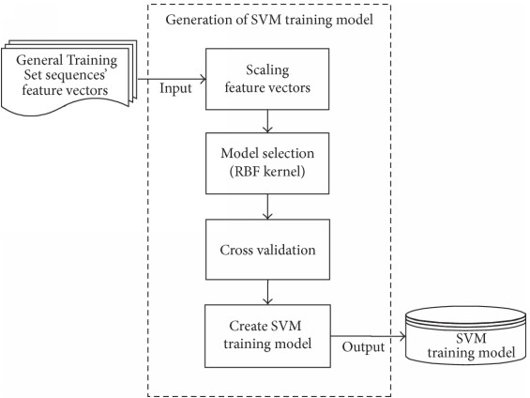

**Fig:5.5.1.1**: Training SVM Model

## CHAPTER 6:

## Cost effectiveness of project

## Reduced Labor Costs: Brain tumor detection automates tasks traditionally requiring manual intervention, reducing associated labor costs. The algorithms efficiently analyze medical images, eliminating the need for extensive human involvement in the diagnostic process. This not only accelerates the detection timeline but also minimizes expenses related to manpower. By streamlining and automating repetitive tasks, healthcare providers can allocate resources more effectively, focusing human efforts on nuanced aspects of diagnosis and patient care. This labor cost reduction enhances the overall cost-effectiveness of brain tumor detection, making advanced technologies an economically efficient solution in the medical field.

## Optimized Resource Allocation: Automated image segmentation techniques streamline the diagnostic process, ensuring efficient use of resources by focusing on specific regions of interest within brain images.

## Time Efficiency: The use of convolutional neural networks (CNNs) accelerates the classification of tumors, significantly reducing the time required for analysis and contributing to overall time efficiency in the diagnostic process

## Elimination of Repetitive Tasks: Machine learning algorithms efficiently handle repetitive image processing tasks, allowing medical professionals to focus on more complex aspects of diagnosis and patient care.

## Swift and Accurate Diagnosis: Rapid and accurate diagnosis facilitated by machine learning algorithms can lead to timely interventions, potentially reducing the overall cost of healthcare by addressing medical issues at an earlier stage.

## CONCLUSION

The identification of abnormal tissue growth in the brain, leading to disruptions in normal brain function, constitutes a brain tumor. In the realm of medical image processing, the primary objective is to extract precise and meaningful information utilizing algorithms with minimal error. The process of brain tumor detection and classification through MRI images involves four key stages: pre-processing, image segmentation, feature extraction, and image classification. This project explores various segmentation methodologies, ultimately concluding that the region growing approach, particularly when coupled with the particle swarm optimization algorithm, yields superior results**.**

While boundary and edge-based approaches are common in segmentation, the region growing approach stands out for its effectiveness. The utilization of the particle swarm optimization algorithm demonstrates notably accurate tumor segmentation. In the context of tumor diagnosis, where the accuracy and reliability of results significantly impact patient outcomes, the proposed methodology stands as a crucial advancement. The emphasis on accuracy is paramount, as the predictive results generated by the system directly influence patient treatment and prognosis. In essence, this methodology not only enhances accuracy but also contributes to obtaining desired outcomes in brain tumor detection through machine learning approaches.

IEEE Papers:

## REFERENCES

1. Wagner MW, Namdar K, Napoleone M, Hainc N, Amirabadi A, Fonseca A, Laughlin S, Shroff MM, Bouffet E, Hawkins C, Khalvati F, Bartels U, Ertl-Wagner

BB. Radiomic Features Based on MRI Predict Progression-Free Survival in Pediatric Diffuse Midline Glioma/Diffuse Intrinsic Pontine Glioma. Can Assoc Radiol J. 2023 Feb;74(1):119-126. doi: 10.1177/08465371221109921. Epub 2022 Jun 29. PMID: 35768942

1. X. Liu et al., "Automatic Segmentation of Rare Pediatric Brain Tumors Using Knowledge Transfer From Adult Data," 2023 IEEE 20th International Symposium on Biomedical Imaging (ISBI), Cartagena, Colombia, 2023, pp. 1-4, doi: 10.1109/ISBI53787.2023.10230757.
2. L. Ramya and N. Sasirekha, "A robust segmentation algorithm using morphological operators for detection of tumor in MRI," 2015 International Conference on Innovations in Information, Embedded and Communication Systems (ICIIECS), Coimbatore, India, 2015, pp. 1-4, doi: 10.1109/ICIIECS.2015.7192927.
3. Leiner, Tim, et al. "Machine learning in cardiovascular magnetic resonance: basic concepts and applications." Journal of Cardiovascular Magnetic Resonance 21.1 (2019): 61.